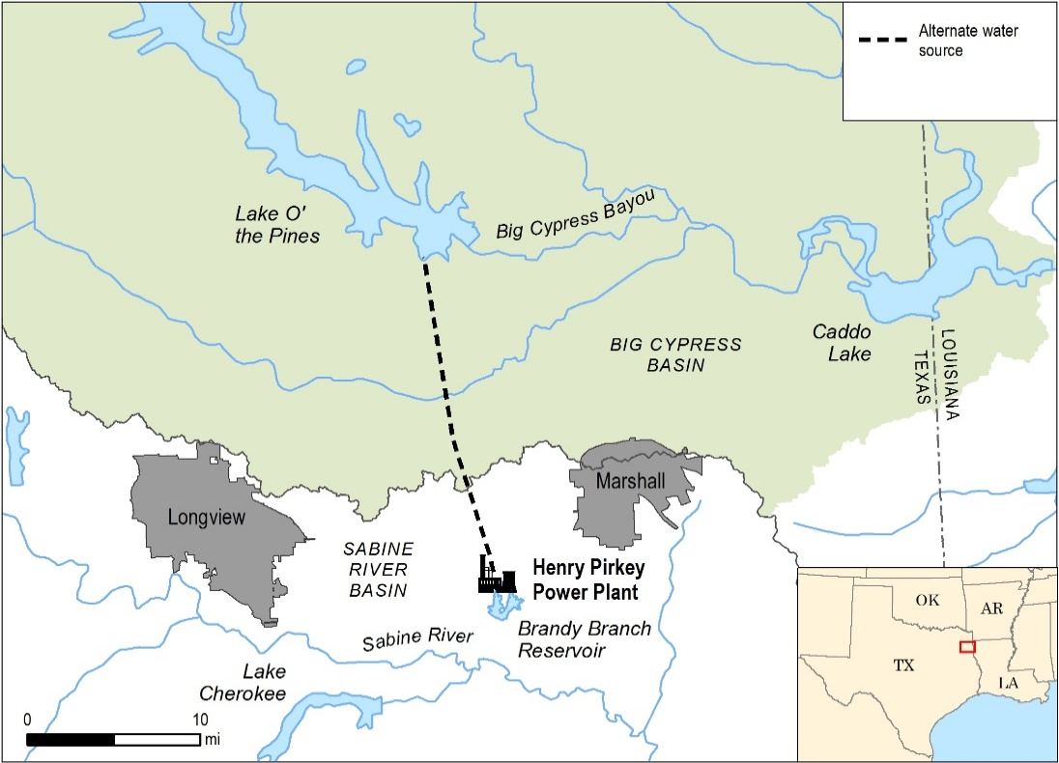
OVERVIEW
The Henry W. Pirkey Power Plant (Pirkey) is a 721 MW lignite-coal fired power plant located in Harrison County, TX (population ~67,000) that is owned and operated by Southwestern Electric Power Company (SWEPCO), a subsidiary of AEP. On average, Harrison receives ~51 inches of rain each year. Summers are hot and humid with average high temperatures in the 90’s (°F). Summer temperatures above 100°F are not uncommon.
Pirkey is located in the Sabine River Basin but currently pumps up to 13 MGD of surface water from Lake O’ the Pines in the Cypress Creek Basin. This interbasin transfer water is used as make-up water for the Brandy Branch Reservoir, which acts as a recirculating cooling pond for Pirkey.
BACKGROUND
Brandy Branch Reservoir was constructed in 1983 to provide a cooling reservoir for Pirkey. This option was preferred over a cooling tower system due to land availability and lower cost. The reservoir is an impoundment of Brandy Branch, a small intermittent creek with a drainage area of 4.1 miles² and an average flow of less than 5 cfs. Due to these characteristics, Brandy Branch Reservoir was originally not subject to Clean Water Act §316(a) regulations; however, the reservoir depends on a steady source of makeup water to account for natural and forced evaporation.
 | Driver | Benefit |  | Challenge
Quantity | 
Quality
Reputation
Regulatory
Cost
DRIVERS
Water supply was the main driver for the interbasin transfer at Pirkey. With very little natural inflow, Brandy Branch Reservoir requires makeup water to replace evaporated water.
Initially, the Sabine River Authority was contacted to determine the availability of using water released from upstream reservoirs along the Sabine River, which is approximately two miles away. An economic comparison of water from the Sabine and Cypress basins was then conducted by SWEPCO. The analysis indicated that water from the Cypress Basin was expected to be the more cost effective source over the life of the plant.
Other potential water sources were identified and assessed as well. The groundwater table in the area is fairly high, but is not productive enough to be used for cooling water, so it was not investigated as an alternative. Lake Cherokee, a reservoir in the Sabine River Basin that supplies water to the Knox Lee Power Plant, is close; however, it was already fully allocated. Several other impoundments on the Sabine River were considered, but these options were dismissed for economic and viability reasons.
Thus, Lake O’ the Pines was identified as the preferred source because a sufficient quantity of water was available, it was expected to be more cost-effective than water from the Sabine basin, and SWEPCO already had an existing 20-year relationship with the Northeast Texas Municipal Water District. The quality of the water is similar in the Cypress and Sabine River Basins, which suggested that there would be no operational issues involving the water. In addition, the water district agreed to absorb all conveyance losses between the Lake O’ the Pines dam and Pirkey’s pump station below the dam.
IMPLEMENTATION
Lake O’ the Pines provides a fairly close cooling-pond makeup water source for Pirkey. The lake was placed in operation in 1959 for flood control, recreation, and water supply and is owned and operated by the U.S. Army Corps of Engineers. The storage capacity is 241,363 acre-feet and it encompasses 17,638 acres. The water rights in the conservation pool are held by the Northeast Texas Municipal Water District.
After constructing the 3,560 foot long earth fill dam in 1983 across Brandy Branch to create the Brandy Branch Reservoir, SWEPCO installed and paid for a 19 mile pipeline north to Lake O’ the Pines. They also built a supplemental pump station about one mile downstream of Lake O’ the Pines.
Brandy Branch Reservoir was filled prior to Pirkey beginning operations. Currently, approximately 11,000 acre-feet/yr. (~9.81 MGD) of water is transported from a supplemental pump station one mile downstream of Lake O’ the Pines into the Brandy Branch Reservoir. The water contract allows for the consumptive use of all 18,000 acre-feet of water and there is no required discharge of the purchased water to the Sabine River Basin.
SWEPCO pays the Northeast Texas Municipal Water District $15/acre-foot for the water diverted and $20.43 for water stored. It is estimated that the costs of the water would be similar if it was taken from the Sabine River Basin. In addition to paying for the installation of the pipeline and supplemental pumping station, SWEPCO also pays for the maintenance and pumping costs. SWEPCO has also obtained a contractual permit from the State of Texas that formally recognizes the contract between SWEPCO and the water district and a Corps of Engineers 404 permit for the intake structure on Big Cypress Creek.
Water from the Brandy Branch Reservoir was initially also used for potable water at Pirkey, but around 2009 the plant switched to using a local water supplier.
BENEFITS & CHALLENGES
Benefits of the interbasin transfer include feasibility due to timing of interbasin transfer regulations, providing Pirkey with a reliable supply of water, reducing flow-related regulatory requirements, and creating a reservoir that offers recreational benefits for the community.
Regulations related to interbasin transfers in Texas are more restrictive today as compared to when the Pirkey plant transfer was established. In the 1980s, interbasin transfers were defined by a 1960’s Texas Supreme Court ruling stating that an interbasin transfer permit would be denied if “the benefits from the diversions were outweighed by detriments to the originating basin.” This did not limit the use of interbasin transfers except in extreme situations where they would negatively impact the original basin. These flexible regulations provided a benefit to SWEPCO.
The 1997 Senate Bill 1 defined a number of new restrictions to interbasin transfers, making it difficult to initiate interbasin transfers in Texas. A “junior-rights provision” requires that when water is transferred from one watershed to another, it becomes the most junior water right in the original basin, thereby making it the first right to get cut during a drought. This regulation has greatly reduced initiation of interbasin transfers in Texas.
Due to the fairly senior water rights of Lake O’ the Pines, it is well protected and provides a reliable supply of water to Pirkey even during drought conditions. The Sabine River Compact, an interstate compact between Louisiana and Texas, allocates waters of the Sabine River to ensure minimum flows and equitable distribution. Hypothetically, this could require the Brandy Branch Reservoir, a fairly junior water user, to release water during times of drought to ensure adequate flow in the Sabine River. However, since a majority of the water in the reservoir is from the Cypress basin rather than the Sabine basin, there is a low likelihood that stored water would have to be released from Brandy Branch Reservoir during times of drought.
Texas Senate Bill 3, passed in 2007, requires environmental flow criteria for all major basins that flow into the Gulf of Mexico in the State of Texas; however, it did not affect Pirkey’s water supply. The Cypress Creek Basin was a lower priority in Senate Bill 3 than the Sabine River Basin because the Cypress does not flow into Texas’ coastal waters. Therefore, because most of the Pirkey water originates from Cypress and the water right was permitted prior to 2007, releases for instream flow requirements from the Brandy Ranch Reservoir are not anticipated to be required.
Brandy Branch Reservoir also provides recreational opportunities for the community and thus positive reputational benefits for SWEPCO and Pirkey. The Pirkey Environmental Park on the reservoir provides opportunities for camping and nature viewing and the reservoir is known for recreational fishing (e.g., largemouth bass, bluegill sunfish, redear sunfish, and channel catfish).
Challenges involving the water use at Pirkey include pipeline failures, additional water use to account for natural evaporation from Brandy Branch Reservoir, pumping station maintenance, and potential challenges with local stakeholders from Caddo Lake.
The initial 36-inch concrete cylinder pipe that was used to transport the water has experienced leaks and some sections required repairs. Additionally, high groundwater levels appear to have contributed to the failure of the wire wrap for the pipe, which exacerbated the leaks. In 2012, a surge tank with air cushioning was installed at the intake to mitigate surges and extend the life of the pipeline.
Challenges have also arisen because the dam at Lake ‘O the Pines cannot be controlled to the desired level of precision. This has caused the Northeast Texas Municipal Water District to sometimes release more water at Lake O’ the Pines than desired to accommodate the supplemental pump station that pumps the water for Pirkey and other downstream users. It should be noted that this additional water is beneficial to the environment, especially during low flow periods.
Caddo Lake, downstream of Lake O’ the Pines, is a highly valued resource with an active watershed group. The Caddo Lake Institute has not directly opposed the upstream diversion of water to Pirkey, but SWEPCO noted different perspectives on water needs between their organizations.
LESSONS LEARNED
Interbasin transfers employed in the past can be an effective solution because they predate current regulations.
An interbasin transfer has the potential to provide quality water to a power plant in need, but understanding the pertinent laws and regulations in the state is crucial. Pirkey was able to easily utilize water from a different basin, but subsequent regulations would have severely limited, or blocked, the ability of the plant to acquire an interbasin transfer for water supply.
Seniority of water rights can be important in areas that are susceptible to droughts and water shortages.
Utilizing water from a source with senior water rights allowed Pirkey to maintain a water supply with a low risk of being cut off or reduced during droughts. Newer bodies of water with junior water rights are more likely to be required to release water during times of drought to maintain minimum flows downstream, thereby increasing the risk that water would not be available for power plant cooling. Recently implemented regulations (e.g., Texas 1997 Senate Bill 1) may remove the senior water rights privileges of the original source in the case of an interbasin transfer.
REFERENCES
Gooch, T. C. and M. J. Taylor. 1999. Comprehensive Sabine Watershed Management Plan. Prepared for the Sabine River Authority of Texas in Conjunction with the Texas Water Development Board. URL: http://www.sratx.org/srwmp/comprehensive_plan/final_report/pdf/CSWMP.pdf [Accessed 11/30/2016].
McCloud, S. 2015. SWEPCO’s Commitment to a Cleaner Environment: Earth Day, Every Day. URL: https://www.swepco.com/info/news/viewRelease.aspx?releaseID=1749 [Accessed 11/29/2016].
Northeast Texas Municipal Water District. 2016. URL: http://www.netmwd.com/ [Accessed 11/30/2016].
Personal communication, AEP staff, 2016. Tim Lohner and Greg Carter.
Schnier, W. 2014. The Politics of Interbasin Water Transfers. BRD Engineering and Consulting. 8/18/2014. URL: https://bigreddog.com/the-politics-of-interbasin-water-transfers/ [Accessed 12/1/2016].
Texas Water Development Board. River Basins. URL: http://www.twdb.texas.gov/surfacewater/rivers/river_basins/ [Accessed 11/30/2016].
USEPA. 1982. Henry W. Pirkey Power Plant, Unit-1/South Hallsville Surface Lignite Mine Project, Harrison County, Texas. Draft Environmental Impact Statement. EPA 906/9-82-004, March 1982.
VERIFICATION
Water use information presented in this case study was provided through interviews with AEP-SWEPCO staff in October 2016, who have reviewed this case study for accuracy.

